**Port Mapping from Docker Host to container**

**1. Create and start an apache application container from image httpd in detached mode using docker run -d command, use -p option to bind the host port to container port.**

[root@ip-172-31-20-5 ~]# docker run -d -p 80:80 httpd

5a8d07c5a5b080885178fb472c03b05a45b2f8e1ce78d65f15e41bcbe94332c4

[root@ip-172-31-20-5 ~]# docker ps

CONTAINER ID IMAGE COMMAND CREATED STATUS PORTS NAMES

5a8d07c5a5b0 httpd "httpd-foreground" 3 seconds ago Up 2 se conds 0.0.0.0:80->80/tcp reverent_leakey

**2. Verify the container status is UP using docker ps command, also see the port mapping rule in the ports section**

# docker ps

"NetworkSettings": {

"Bridge": "",

"SandboxID": "af9b58e8a7b86e73dd6d54358facf0f0e8404ca2f6ecc7d10533676306487967",

"HairpinMode": false,

"LinkLocalIPv6Address": "",

"LinkLocalIPv6PrefixLen": 0,

"Ports": {

"80/tcp": [

{

"HostIp": "0.0.0.0",

"HostPort": "80"

}

]

},

**3. Copy the EC2 PublicIP of Docker Host from AWS Console, paste it in browser to**

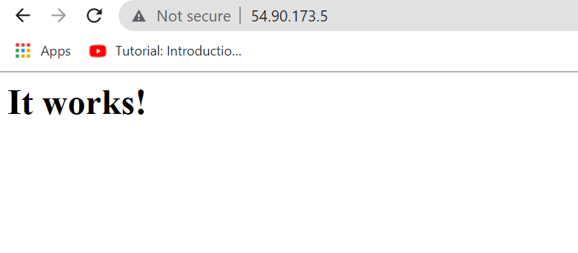

**4. Use the command docker exec -it to get a shell in the container.Exit from the container and check the docker container status. It will be still up as we entered the shell as a secondary process and for this container primary**

**process is apache**

[root@ip-172-31-20-5 ~]# docker exec -it 5a8d07c5a5b0 /bin/sh

# exit

**5. Use the command docker exec -it to get back to the shell of the container. Apply kill command on the primary process of the container (PID 1). The container will be exited as the primary process got exited .**

[root@ip-172-31-20-5 ~]# docker exec -it 5a8d07c5a5b0 /bin/sh

# kill 1

# [root@ip-172-31-20-5 ~]# docker ps -a

CONTAINER ID IMAGE COMMAND CREATED STATUS PORTS NAMES

5a8d07c5a5b0 httpd "httpd-foreground" 4 minutes ago Exited (0) 2 seconds ago reverent_leakey

**8. Clean up of resources created in this lab.**

# docker container stop < container id/name >

# docker container rm < container id/name >

# docker image rm < image id >